**Installing Elasticsearch in windows machine**

Step 1:

Go to the website : <https://www.elastic.co/downloads/elasticsearch> and click on the “WINDOWS” under “Downloads” links. A zip file will be downloaded.

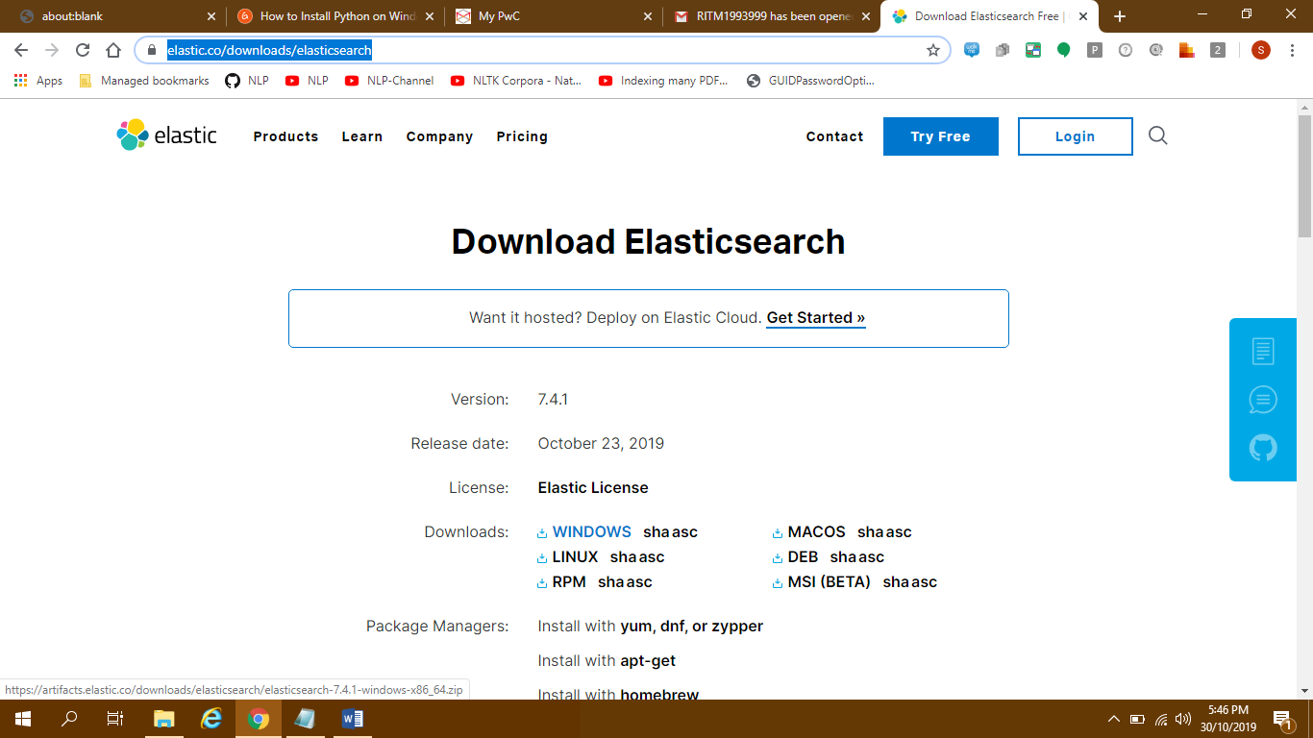

Step 2: Extract the zip file to any folder. Its name should be something like “elasticsearch-7.x.x”. Go inside this folder.

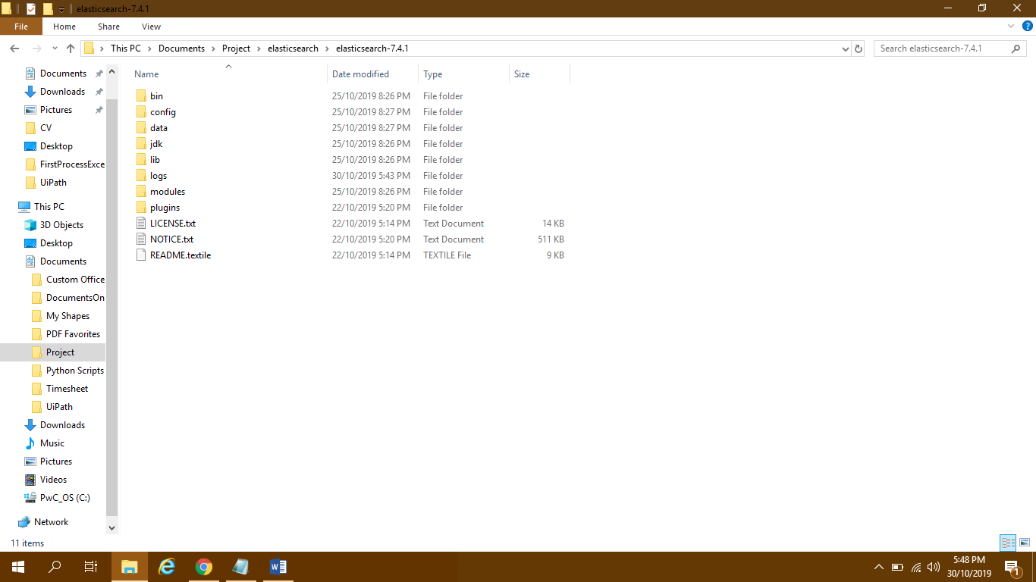

Step 3: Go inside “bin” folder and run the “elasticsearch.bat” file. A command prompt should open.

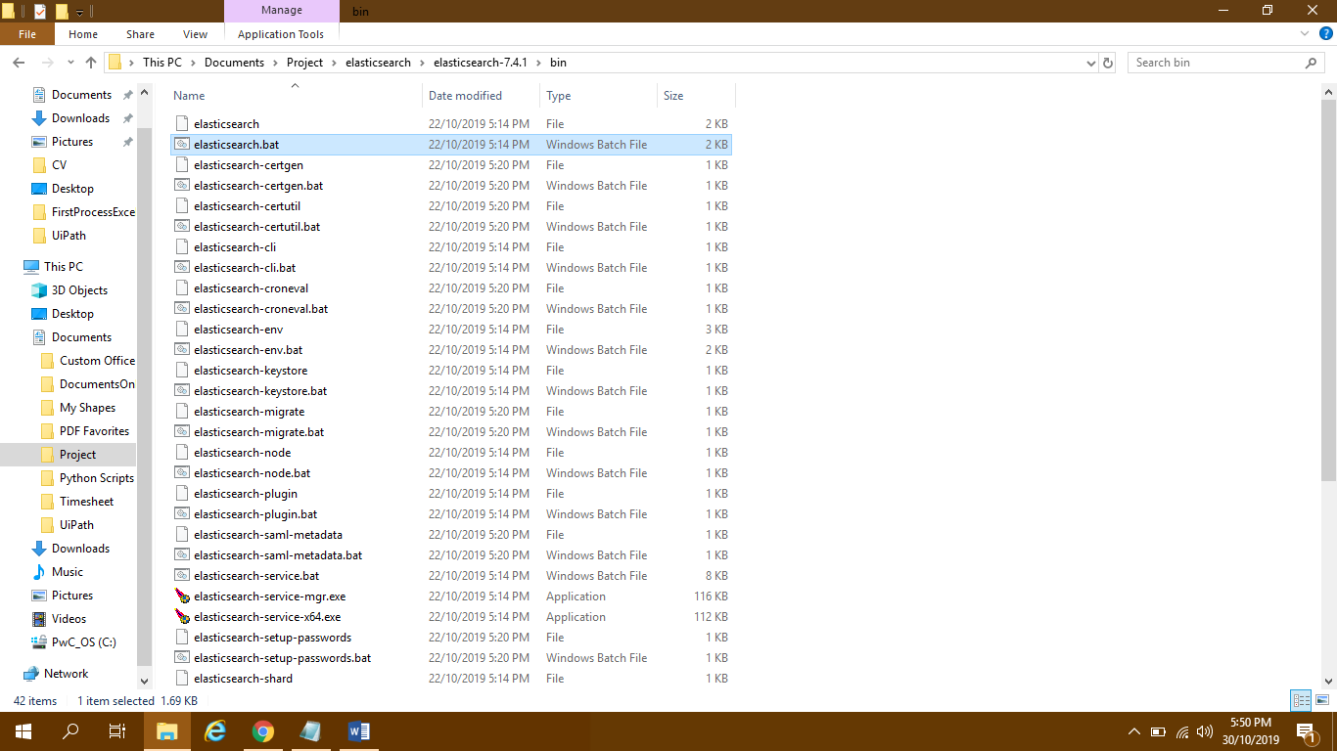

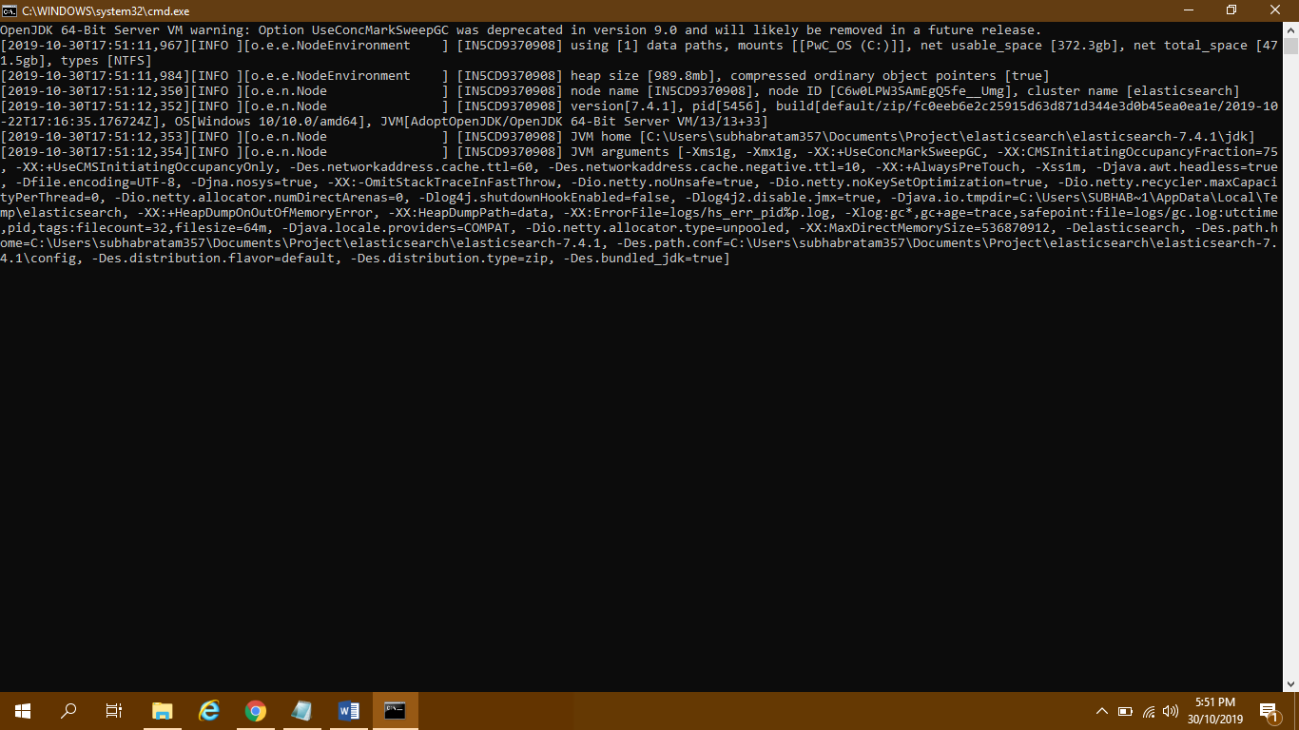

Step 4: Look for the line “[2019-10-30T17:51:37,300][INFO ][o.e.n.Node ] [IN5CD9370908] started” in command prompt and then your elasticsearch is up and running.

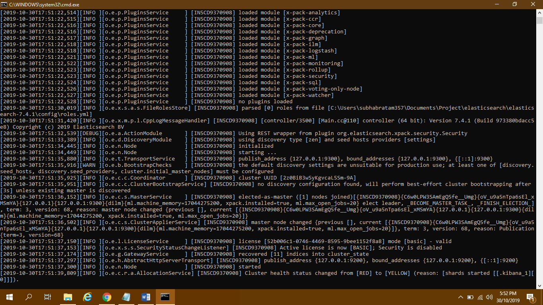

Step 5: Go to chrome or IE and hit url: localhost:9200. You should see the below text:

{

"name" : "IN5CD9370908",

"cluster_name" : "elasticsearch",

"cluster_uuid" : "2z0BiB3wSyKgvcaL5Sm-9A",

"version" : {

"number" : "7.4.1",

"build_flavor" : "default",

"build_type" : "zip",

"build_hash" : "fc0eeb6e2c25915d63d871d344e3d0b45ea0ea1e",

"build_date" : "2019-10-22T17:16:35.176724Z",

"build_snapshot" : false,

"lucene_version" : "8.2.0",

"minimum_wire_compatibility_version" : "6.8.0",

"minimum_index_compatibility_version" : "6.0.0-beta1"

},

"tagline" : "You Know, for Search"

}

If it is showing like this, your elasticsearch is successfully set up for localhost and port 9200. You can change the port from config/elasticsearch.yml file.

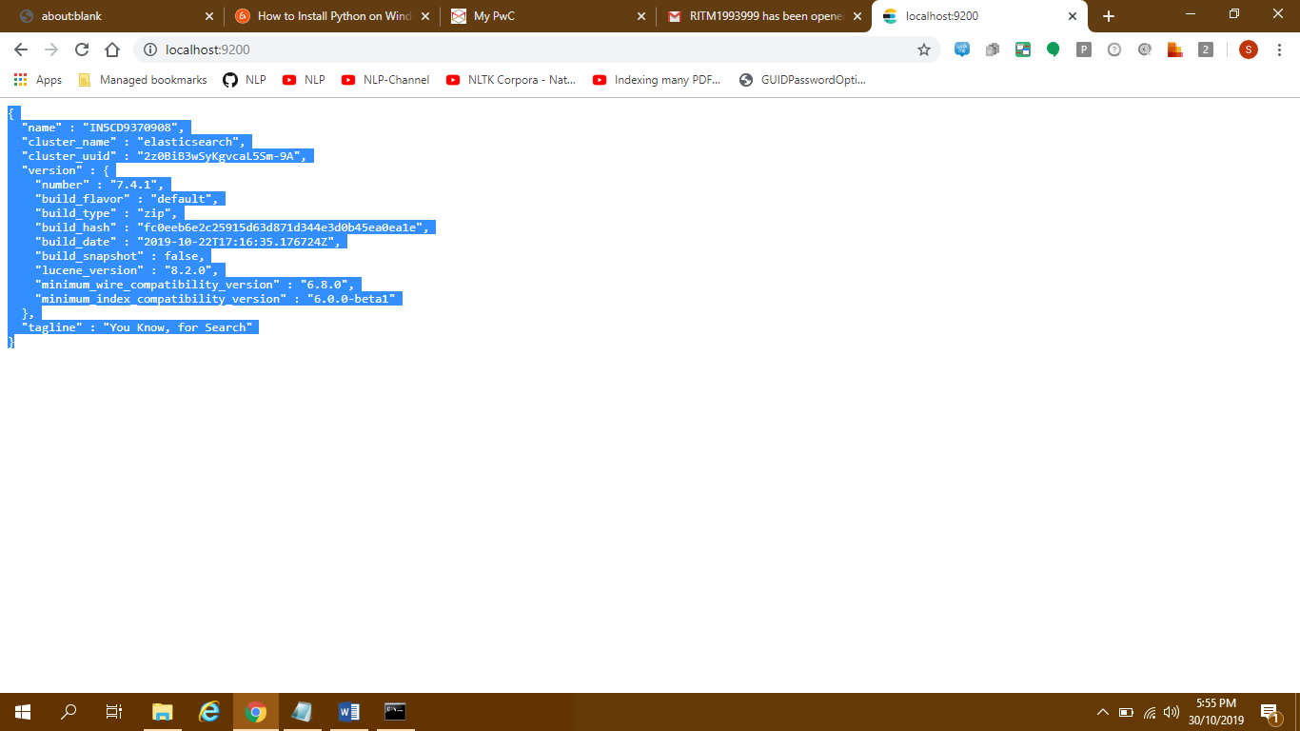

Step 6: Now you need to install kibana. Go to the url: <https://artifacts.elastic.co/downloads/kibana/kibana-7.4.1-windows-x86_64.zip>

Once downloaded please extract the zip files into a folder. The extracted folder name should be like kibana-7.4.1-windows-x86_64

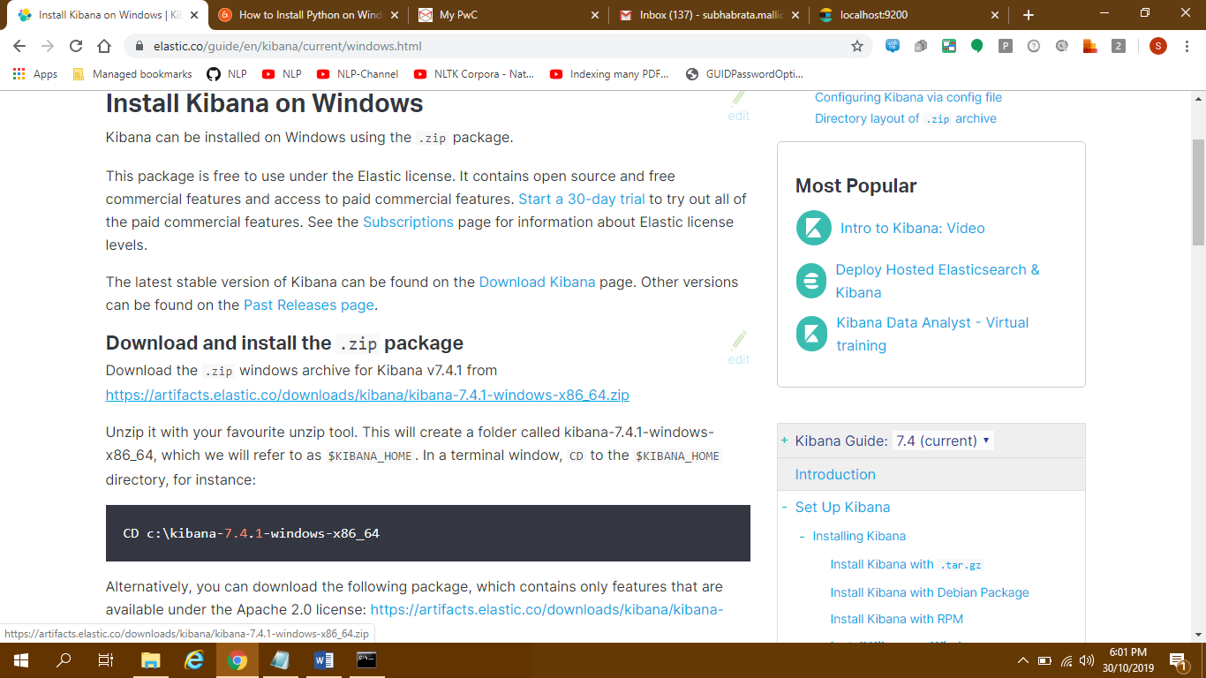

Step 7: Inside the folder go into bin and run kibana.bat. You should see a command prompt running.

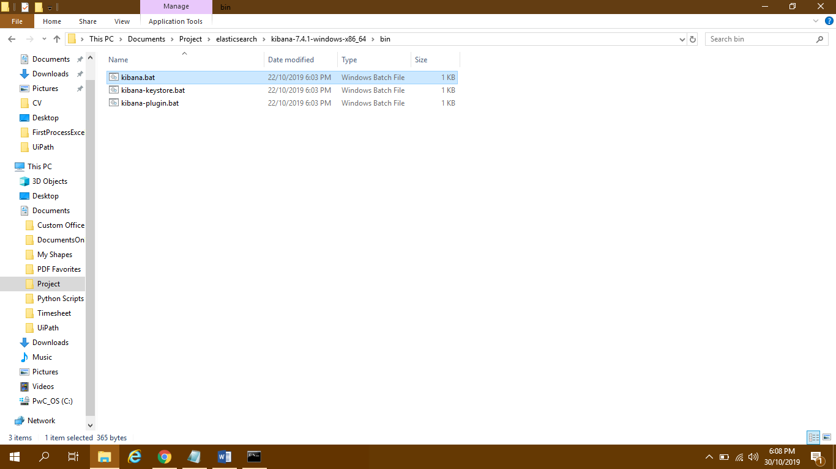

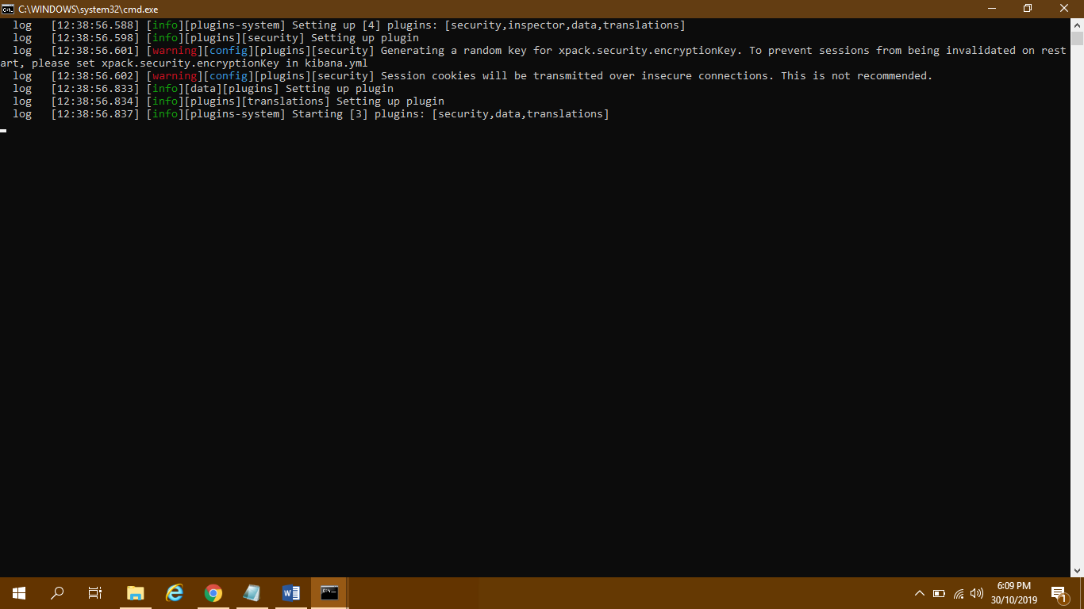

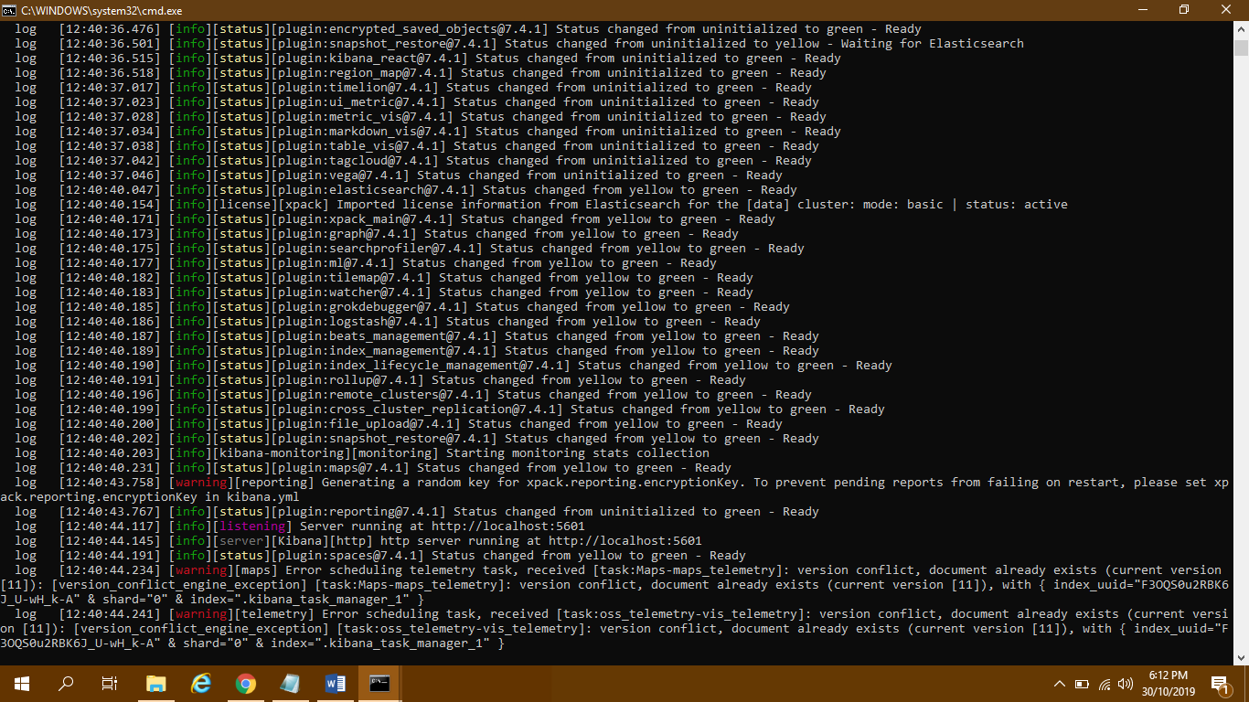

Step 8: Now type <http://localhost:5601/app/kibana> in your browser address bar and hit enter. You should show some screen like below. Kibana is successfully installed.

